# Battle of the Neighborhoods[¶](http://localhost:8888/notebooks/C%3A%5CUsers%5Cvkuma140%5CMusic%5CInterview%20point%5CIBM%20VISUALIZATION%5CMachine%20Learning%5Cml_capstone%5CThe%20Battle%20of%20Neighborhoods%20(Week%202).ipynb##-Battle-of-the-Neighborhoods)

Indian Restaurants[¶](http://localhost:8888/notebooks/C%3A%5CUsers%5Cvkuma140%5CMusic%5CInterview%20point%5CIBM%20VISUALIZATION%5CMachine%20Learning%5Cml_capstone%5CThe%20Battle%20of%20Neighborhoods%20(Week%202).ipynb" \l "Indian-Restaurants)

Introduction[¶](http://localhost:8888/notebooks/C%3A%5CUsers%5Cvkuma140%5CMusic%5CInterview%20point%5CIBM%20VISUALIZATION%5CMachine%20Learning%5Cml_capstone%5CThe%20Battle%20of%20Neighborhoods%20(Week%202).ipynb#Introduction)

This final project explores the best locations for Indian restaurants throughout the city of New York. Food Business/Entrepreneur News stated that worldwide Indian Food sales were up for the second year in a row with the United Sates holding the largest market (Donley, 2018). New York is a major metropolitan area with more than 8.4 million (Quick Facts, 2018) people living within city limits. Most of the Indian immigration into the United States occurred during the late 19th and early 20th century with over two million immigrants between 1900 and 1910. With almost 600,000 Manhattan inhabitants reporting Indian ancestry, the need to find and enjoy Indian cuisine is on the rise. This report explores which neighborhoods and boroughs of New York City have the most as well as the best Indian restaurants. Additionally, I will attempt to answer the questions “Where should I open an Indian Restaurant?” and “Where should I stay If I want great Indian food?”

Data[¶](http://localhost:8888/notebooks/C%3A%5CUsers%5Cvkuma140%5CMusic%5CInterview%20point%5CIBM%20VISUALIZATION%5CMachine%20Learning%5Cml_capstone%5CThe%20Battle%20of%20Neighborhoods%20(Week%202).ipynb#Data)

In order to answer the above questions, data on New York City neighborhoods, boroughs to include boundaries, latitude, longitude, restaurants, and restaurant ratings and tips are required.

New York City data containing the neighborhoods and boroughs, latitudes, and longitudes will be obtained from the data source: <https://cocl.us/new_york_dataset>

New York City data containing neighborhood boundaries will be obtained from the data source: <https://data.cityofnewyork.us/City-Government/Borough-Boundaries/tqmj-j8zm>

All data related to locations and quality of Italian restaurants will be obtained via the Four-Square API utilized via the Request library in Python.

Methodology[¶](http://localhost:8888/notebooks/C%3A%5CUsers%5Cvkuma140%5CMusic%5CInterview%20point%5CIBM%20VISUALIZATION%5CMachine%20Learning%5Cml_capstone%5CThe%20Battle%20of%20Neighborhoods%20(Week%202).ipynb#Methodology)

• Data will be collected from <https://cocl.us/new_york_dataset> and cleaned and processed into a dataframe.

• FourSquare be used to locate all venues and then filtered by Indian restaurants. Ratings, tips, and likes by users will be counted and added to the dataframe.

• Data will be sorted based on rankings

• Finally, the data be will be visually assessed using graphing from various Python libraries.

Problem Statement[¶](http://localhost:8888/notebooks/C%3A%5CUsers%5Cvkuma140%5CMusic%5CInterview%20point%5CIBM%20VISUALIZATION%5CMachine%20Learning%5Cml_capstone%5CThe%20Battle%20of%20Neighborhoods%20(Week%202).ipynb#Problem-Statement)

1. What is / are the best location(s) for Indian cuisine in New York City?
2. In what Neighborhood and/or borough should I open an Indian restaurant to have the best chance of being successful?
3. Where would I go in New York City to have the best Indian food?

As a database, I used GitHub repository in my study. My master data which has the main components Borough, Neighborhood, Latitude and Longitude information’s of the city.

|  | **Borough** | **Neighborhood** | **Latitude** | **Longitude** |
| --- | --- | --- | --- | --- |
| **0** | Bronx | Wakefield | 40.894705 | -73.847201 |
| **1** | Bronx | Co-op City | 40.874294 | -73.829939 |
| **2** | Bronx | Eastchester | 40.887556 | -73.827806 |
| **3** | Bronx | Fieldston | 40.895437 | -73.905643 |
| **4** | Bronx | Riverdale | 40.890834 | -73.912585 |

import matplotlib.pyplot as plt

col = "green"

NY\_data.groupby('Borough')['Neighborhood'].count().plot.bar(figsize=(10,5), color=col)

plt.title('Neighborhoods per Borough: NYC', fontsize = 20)

plt.xlabel('Borough', fontsize = 15)

plt.ylabel('No. Neighborhoods',fontsize = 15)

plt.xticks(rotation = 'vertical')

plt.show()

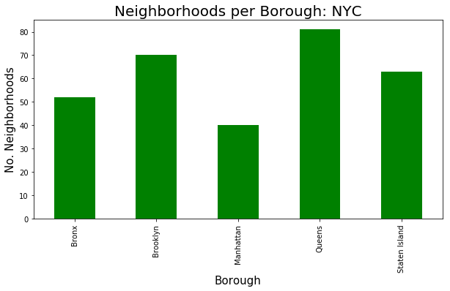

NOofNeigh = 6 # top number for graphing all the same past 6

colo='pink'

indian\_rest\_ny.groupby('Neighborhood')['ID'].count().nlargest(NOofNeigh).plot.bar(figsize=(10,5), color=colo)

plt.title('Indian Resturants per Neighborhood: NYC', fontsize = 20)

plt.xlabel('Neighborhood', fontsize = 15)

plt.ylabel('Indian Resturants', fontsize=15)

plt.xticks(rotation = 'horizontal')

plt.show()

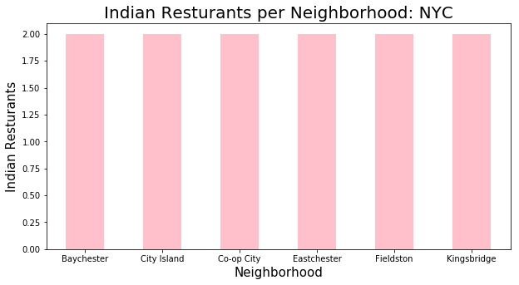

col1='brown'

indian\_rest\_ny.groupby('Borough')['ID'].count().plot.bar(figsize=(10,5), color = col1)

plt.title('Indian Resturants per Borough: NYC', fontsize = 20)

plt.xlabel('Borough', fontsize = 15)

plt.ylabel('No.of Indian Resturants', fontsize=15)

plt.xticks(rotation = 'horizontal')

plt.show()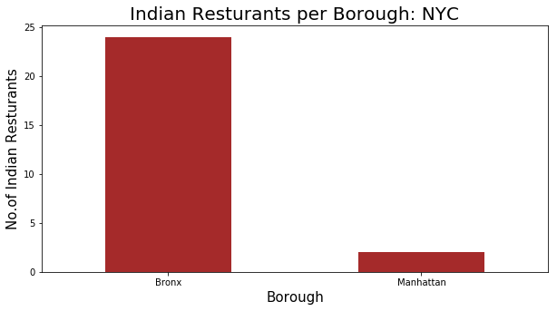

We can see the number of Indian Restaurants in “Baychester” Neighborhood.

indian\_rest\_ny[indian\_rest\_ny['Neighborhood']=='Baychester']

|  | **Unnamed: 0** | **Borough** | **Neighborhood** | **ID** | **Name** |
| --- | --- | --- | --- | --- | --- |
| **20** | 20 | Bronx | Baychester | 575dea4c498e2739e43a27e2 | Aahar Indian Cuisine |
| **21** | 21 | Bronx | Baychester | 50b02338e4b047828b2277c1 | Benares |

indian\_rest\_ny[indian\_rest\_ny['Neighborhood']=='City Island']

|  | **Unnamed: 0** | **Borough** | **Neighborhood** | **ID** | **Name** |
| --- | --- | --- | --- | --- | --- |
| **24** | 24 | Bronx | City Island | 575dea4c498e2739e43a27e2 | Aahar Indian Cuisine |
| **25** | 25 | Bronx | City Island | 50b02338e4b047828b2277c1 | Benares |

You can now see Join, Labels and Level\_labels columns as the last three ones in above table. You can also see a clustered map boroughs of New York Indian Restaurant in the below.

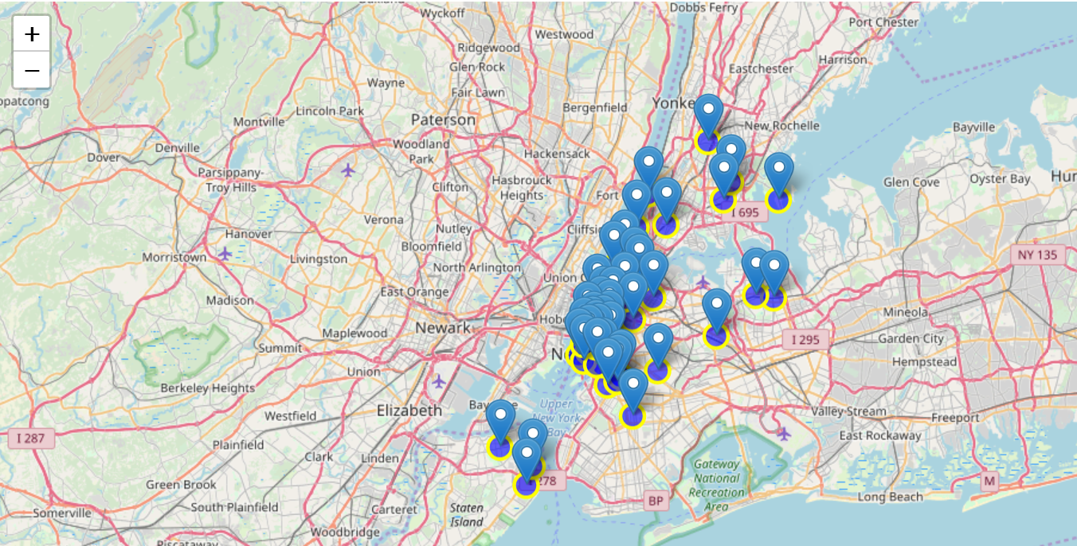

# Results / Conclusion[¶](http://localhost:8888/notebooks/C%3A%5CUsers%5Cvkuma140%5CMusic%5CInterview%20point%5CIBM%20VISUALIZATION%5CMachine%20Learning%5Cml_capstone%5CThe%20Battle%20of%20Neighborhoods%20(Week%202).ipynb#Results-/-Conclusion)

Bronx and Manhattan have the best rated Indian restaurants on average. The Bronx has the highest number of Indian restaurants per borough. However, of note, Baychester, City Island, and co-op city etc. has the neighborhood in all of NYC with the same Indian Restaurants. Despite Manhattan having the least number of neighborhoods as comparison to Bronx but, it has the most Indian restaurants. Based on this information, I would state that Manhattan and Bronx are the best locations for Indian cuisine in NYC. To have the best shot of success, I would open an Indian restaurants in Bronx. Bronx has multiple neighborhoods with average ratings exceeding 8.0 of a scale of 1.0 to 10.0 and has the least number of Indian restaurants making competition easier than in other boroughs. . As a final note, all of the above analysis is depended on the adequacy and accuracy of Four Square data. A more comprehensive analysis and future work would need to incorporate data from other external databases.

### **G. References**:

[1] [New York Dataset — Wikipedia](https://en.wikipedia.org/wiki/Istanbul)

[2] New York City data containing neighborhood boundaries will be obtained from the data source: <https://data.cityofnewyork.us/City-Government/Borough-Boundaries/tqmj-j8zm>

[3] [Forsquare API](https://developer.foursquare.com/" \t "_blank)